Der kleine Test zum Wetter
4
3
2
1
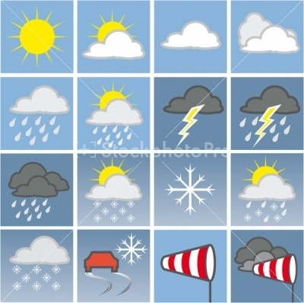
16
15
14
13
11
12
1010
9
8
7
6
5
- _____________________ 9._______________________
- _____________________ 10.______________________
- _____________________ 11._______________________
- _____________________ 12.______________________
- _____________________ 13.______________________
- _____________________ 14.______________________
- _____________________ 15.______________________
- _____________________ 16.______________________

